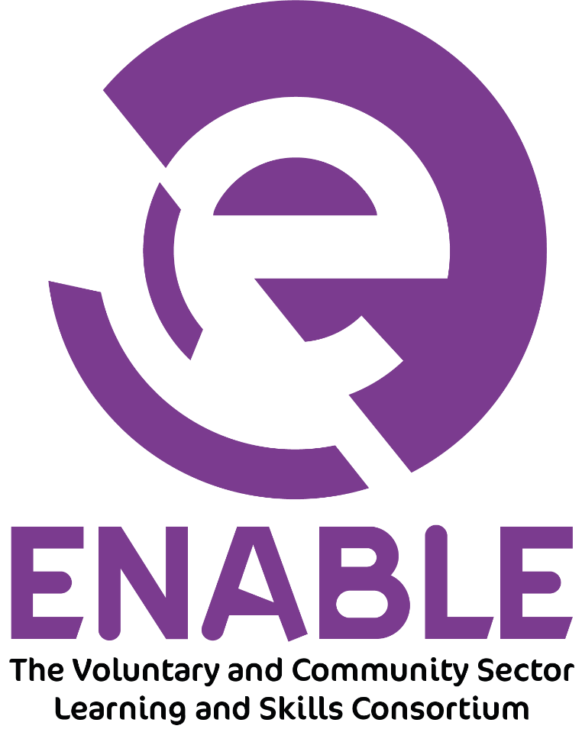

Sub-Contract Management & Fees Policy

Change History

First Published: |  | 2003 |  | Originally Created by: |  | Quality Lead
Person Responsible for Policy: |  |  | Enable CEO
Date of Review | Reviewed by | Policy changes |  |  | Approved by |  | Date of next review
5 July 2018 | Standards Officer | Slight changing to wording |  |  | Operations Manager |  | 23 July 2018
13/09/2018 | CEO | Addition of Headers and Footnote |  |  | Board of Trustees |  | 10/09/2019
01/10/2020 | CEO | Wording added for Lockdown |  |  | SMT |  | 01/10/2021
01/09/2021 | CEO | Review |  |  | Board of Trustees |  | 01/09/2022
07/09/2022 | CEO | Minor formatting |  |  | SMT |  | 07/09/2023

1. Background

Enable was established as a learning and skills consortium in 2003 and currently has 200 registered members. Approximately 25 of these are providing activities via Enable contracts that are funded from the Education and Skills Funding Agency (ESFA). Enable is a consortium based on a ‘hub and spoke’ design. All members of the consortium are partners with Enable, which is vital for them to access and deliver contracts. Membership of Enable is free and open to all voluntary and community sector organisations with an interest in the provision of learning and skills.
This policy describes the fundamental principles by which Enable will implement a fair, open, transparent and robust selection process for potential sub-contractors, taking into account all relevant criteria to ensure compliance.

2. Policy

The objectives of Enable for the year ending 31 July 2023 are:

- To engage with partners who can demonstrate a track record of strong success rates.
- To engage with partners who can demonstrate effective procedures for ensuring full compliance against ESFA funding rules.
- To engage with partners who are actively focused on improving the employability of adult learners and meeting ESFA funding criteria.
- To engage with partners who can meet thresholds for sub-contracting established through the Enable Due Diligence process - to ensure they can meet the criteria laid out in section 3
- To build the capacity of community-based provision within the most disadvantaged communities

3. Procedure

Partner contracts will specify the programmes to be delivered, their maximum contract values, contract and quality management arrangements and target success rates.
Contracts will be subject to regular performance review and may be withdrawn and reduced or otherwise amended where the performance review process indicates that there are reasonable grounds to do so.
Enable will allocate dedicated resource to the selection, management and monitoring of sub-contracted provision.
Each active sub-contractor will be subject to formal performance monitoring on a monthly basis which may take the form of a face-to-face meeting, a telephone conversation or a review of performance data. Enable will take immediate action if a sub-contractor’s performance does not meet expectations. Actions and responses will give consideration to the monitoring deadlines of the Funding Bodies and timescales to take action will be proportionate to the proximity of those deadlines.

Sub-Contractors will:

- Be honest and transparent in their dealings with Enable.
- Respect any commercial confidences shared by Enable at the exploratory stage.
- Undertake their own risk assessment to ensure that they only sign up to a level of business that is within their capability, commercial viability and risk tolerance, and is in line with their mission statement and organisational values.
- Not overestimate the volumes, performance levels or geographical spread they will be able to achieve and will notify Enable of any significant changes to these.
- Maintain understanding of their own performance against profile and projected delivery.
- Give learners the best chance possible of success.
- Regularly communicate with Enable, including timely responses to requests for information.
- Provide up to date, full and accurate information on all learners.
- Ensure the health and safe and safeguarding of all learners.
- Alert Enable if they are experiencing any difficulties, including financial problems, in plenty of time to allow any appropriate support to be offered.
- Ensure that they keep informed about the wider market and its trends.
- Participate and provide feedback in evaluations and reviews.
- Honour commitments made as contracts are delivered.
- Allow Enable staff, funding body representatives, (including auditors) and Ofsted inspectors access to learners, staff, premises and learning records for monitoring purposes.
- Attend meetings and training designed to support the successful delivery of the relevant contracts.
- Ensure the safeguarding of their staff and learners
- Comply with all Enable policies of which they have access to.

Enable will

- Manage the sub-contractors with integrity and openness
- Ensure that all sub-contractors receive clear and consistent communication and guidance, and clearly define and communicate any specific ways of working that sub-contractors are expected to adapt and follow
- Provide high quality and timely performance information as required by the sub-contractor and the funding agencies
- Provide such information as may be relevant to the operation of the contract between Enable and the sub-contractor and disseminate any pertinent information from funding bodies and other agencies.
- Give reasonable notice of any decisions to reduce or discontinue the contractual arrangements with the sub-contractor
- Offer opportunities for sub-contractors to participate in training activities organised by Enable
- Hold partnership network meetings to aid communication and sharing of good practice
- Honour commitments made as contracts are delivered
- Make available support to enable the delivery of qualifications and accredited programmes
- Provide capacity building support to enable sub-contractors to develop and sustain their services

Operational Support

Enable will provide a dedicated and responsive contract management team to deal effectively and efficiently with day-to-day queries relating to funding rules, regulations and requirements.

Prompt payments and a comprehensive payment breakdown

Enable will provide pro-active Finance and Performance Teams who will respond to financial queries and distribute a monthly breakdown showing the amount of funding paid for every learner.
Management fees will be deducted at source; sub-contractors will receive a Maximum Contract Value (MCV) from Enable that reflects their available funds, and any management fee will have been deducted prior to this allocation. Enable will make monthly payments to sub-contractors based on the correct submission of data and supporting evidence that validates learning delivery.

All funding claims must comply with current ESFA Funding rules and the terms of the contract between Enable and its sub-contractors. Where funding claims cannot be substantiated Enable will adjust or reclaim any funds from the sub-contractor, and where required make an appropriate repayment to the ESFA.

4. Fees and Charges

The management fee charged will be 20% of the income received. Subject to determined delivery costs (consisting of programme funding and tuition fees) Enable will provide the following in justification of its management fees:

- Pre-contract assessment, contract management (including performance against maximum funding values), submitting declaration of sub-contractor form to ESFA.
- Data management – where required support with learner eligibility, existence and completeness checks, recording of enrolment data and submission of funding claim to relevant funding body.
- Performance management – to review delivery against profile, where appropriate, and to review retention, achievement and success rates.
- Contract compliance checks - funding compliance checks by Enable staff.
- Quality - observations of teaching and learning, along with quality monitoring visits. (This may take the form of remote visits should conditions dictate such as National lockdown) This will then be used to support an improvement/CPD plan for each individual staff member identified.
- Health and safety support. To include Safeguarding and Mental Health Wellbeing
- Accreditation support for those partners who require it
- Provision of continuity in TLA for learners if a provider’s contract is removed?
- Moderation facilities if required
- Access to Enables E learning platforms and resources
- Support with process/operational changes in events such as National lockdown

5. Processing and Payment of Invoices

Enrolment forms and the supporting evidence should be received by the end of the month. Any paperwork received after the month end will be processed in the following calendar month.

6. Policy Review and Publication

The policy will be reviewed annually and any changes notified to sub-contractors in writing. The policy is available on Enable’s website.

7. Additional Services

In addition to the services listed above, which form part of the standard management functions of Enable contracts, sub-contractors also have access to a wide range of subsidised services available through the consortium. This includes training sessions, use of Enable’s accreditation service for non-contracted delivery, staff development opportunities, marketing support, room hire and consultancy.

Signed:

Position: CEO

Date: 07/09/2022

